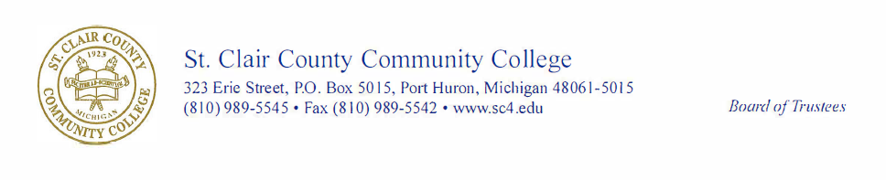
PUBLIC NOTICE
SPECIAL MEETING SCHEDULED
On August 31, 2026, the Board of Trustees of St. Clair County Community College called a special meeting to be held on Tuesday, September 22, 2026, at 4:30 p.m. in the Welcome Center, room 150.
The purpose of this special meeting is for the consideration of appointment of a trustee.
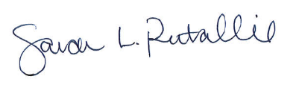

Sarah L. Rutallie
Board Secretary

Notice posted: 9/3/2026

